Cervical Cancer Detection Using XGBoost with Hyperparameter Tuning and Class Imbalance Management

Divya Chawla
B.Tech Information Technology
Indira Gandhi Delhi Technical University for Women
Delhi, India
divyachawla110305@gmail.com
Aditi Kumari
B.Tech Information Technology
Indira Gandhi Delhi Technical University for Women
Delhi, India
k.aditi2105@gmail.com

Abstract— Cervical Cancer is a critical health issue across the globe. As we know that early and accurate prediction is essential to give the patient effective treatment which can ultimately lead to improved survival rates. We aim to develop a robust model using ML and more specifically the XGBoost algorithm that will predict the likelihood of cervical cancer which will in turn help in early diagnosis and better decision making. We focus on the common challenges in medical data analysis such as missing data and class imbalance, which can ultimately come in the way of the performance of predictive models. For addressing class imbalance i.e. when the number of instances for one class is much greater than the other class, the ‘scale_pos_weight’ parameter was adjusted so that the model is able to recognize the minority class as well. Here the majority class is the class 0 or NO Cancer whereas the minority class is the class 1 or Cancer positive. Extensive hyperparameter tuning was performed using GridSearchCV to optimize model performance. We obtained the model results as follows: 96.5% accuracy for the validation set, a 96.89% accuracy on the training set and a 95.3% accuracy for the test set. As the difference between the test set and validation set is not a lot it proves that the model will work sufficiently well on unseen data as well. To sum up, this model demonstrates the potential of XGBoost Algorithm along with hyperparameter tuning for improving early detection of cervical cancer and managing class imbalance.
Keywords— Cervical Cancer, XGBoost, GridSearchCV, accuracy, hyperparameter tuning.

Introduction
Cervical Cancer is a significant health challenge across the globe. It is the fourth most common cancer in women worldwide, and is a leading cause of death for women in resource-poor settings. In 2022, there were about 660,000 new cases of cervical cancer and about 350,000 deaths. Early detection and accurate diagnosis are critical in improving the mortality rates. Traditional methods can be assisted with machine learning models to get even better results.
As we see everyday technology is making advancements in every field. Medical field is also not untouched by it. It can give a major boost in medical field by using complex algorithms on large datasets. XGBoost has demonstrated superior predictive performance compared to other models like logistic regression in medical studies, which is crucial for making accurate diagnoses or risk assessments in precision medicine. Despite the effectiveness of machine learning it still faces the challenge of class imbalance. In many datasets used for medical diagnosis the positive cases are usually in minority which hinders with the accuracy in determining the minority class. In our study we have emphasized on the use of methods like hyperparameter tuning which can help with the class imbalance issue.
We have two objectives for this research basically: first is to develop a machine learning model using XGBoost Algorithm for cervical cancer prediction and second is to use hyperparameter tuning to achieve better accuracy in the minority class. At the end our study is aiming to contribute to the application of machine learning in medical field which can help in the early detection of cancer and improve the survival rate.

Literature Review

Machine Learning’s Impact on Medical Diagnostics
Recent technological advancements make it clear that in medical diagnostics, Machine Learning is a key tool as it analyzes vast amounts of data and gives reasonably accurate results. ML algorithms, which are Support Vector Machines, Random Forests, and Neural Networks, are practical tools that improve clinical decision-making and improve patients' outcomes (Obermeyer & Emanuel, 2016: “Predicting the Future — Big Data, Machine Learning, and Clinical Medicine” and Esteva, A., Kuprel, B., & Novoa, R. A. (2019). "Dermatologist-level classification of skin cancer with deep neural networks."). These can, therefore, be considered invaluable algorithms because of their expert ability to identify patterns in complex datasets.

The Role of XGBoost in Classification
Chen and Guestrin, 2016 in the paper “XGBoost: A scalable tree boosting system” have clearly stated that XGBoost’s ability to manage large datasets and handle complex features make it very effective in medical applications. XGBoost has outperformed other algorithms in classification tasks. XGBoost algorithm is known for its high accuracy and efficiency. Hence, we went ahead and used it in our project.

Challenges with Class Imbalance
Often when we deal with real life medical data, we deal with the challenge of class imbalance which basically means that there are two classes out of which one is present in minority. The model accurately predicts the majority class but fails to predict the minority class accurately. Hence Chawla, N. V., Lazarevic, A., & Hall, L. O. (2002) in their paper discussed "SMOTE: Synthetic minority over-sampling technique." This can be used in future studies.

Hyperparameter Tuning
In order to get the best results hyperparameter tuning is essential. It basically means to search through different settings and find the ones that yield the best results. It has been explored in the paper: “Hyperparameter optimization in learning systems” by Răzvan Andonie. Various techniques like GridSearchCV explore as explained before and optimize parameters like number of trees and learning rate. Proper training is important in order to get the model to perform optimally.

Cervical Cancer and Machine Learning
There has been significant research in predicting cervical cancer using Machine Learning algorithms and it has shown promising results. Al Mudawi and Alazeb in their paper “A Model for Predicting Cervical Cancer Using Machine Learning Algorithms” (2020) proposed a predictive model for cervical cancer using various machine learning algorithms. Their research showed the importance of selecting the appropriate algorithm for the model. For our model we have used XGBoost algorithm.

Methodology
In our study we have used machine learning to predict cancer risk. We have used the dataset from UCI Machine Learning Repository. We have further used data cleaning and have also handled missing values. Then we have split the data into training, validation and test sets. We used the XGBoost algorithm and the reason for choosing it was that it outperforms other algorithms in many cases. We used hyperparameter tuning along with it through GridSearch. Finally, we evaluated the model performance using accuracy, precision, recall, F1 scores and confusion matrices on both validation and test sets in order to ensure the predictive capabilities.
Figure 1 shows a view of our overall research workflow diagram.
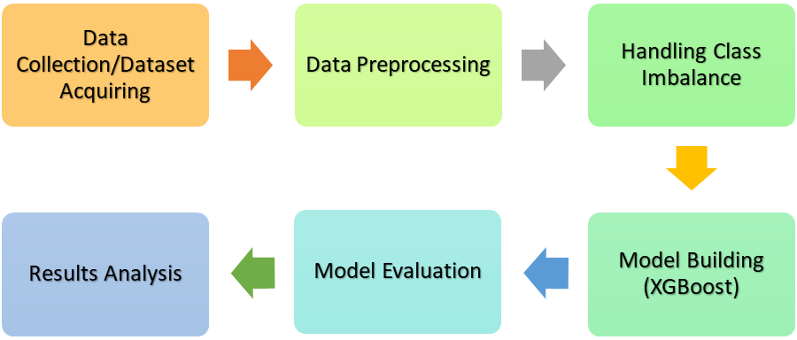
- Overall research workflow diagram.

Data Collection and Preprocessing
- Dataset: The dataset we have used in our study is taken from UCI Machine Learning Repository, specifically the “Cervical Cancer Risk Factors” dataset. The said dataset includes 858 rows and 36 columns. It contains demographic, behavioral and medical information of people with the target variable being “Biopsy” which indicates whether a person is testes positive or negative for cervical cancer.
- Data Loading and Initial Exploration: The dataset was loaded using pandas data frame. Then we explored the basic structure using the info() and describe() functions. We did this just for the understanding of the dataset’s layout, including the number of missing values. We also get to know the type of data in the dataset categorical or numeric.
- Handling Missing Values: In our dataset the missing values were represented by ‘?’ symbol which we replaced with NaN for easier manipulation. We plotted a heatmap (Figure 2) to visualize the distribution of missing values. This highlighted the columns with significant missing data. Since two of the columns STDs: Time since first diagnosis and STDs: Time since last diagnosis had more than or equal to 80% of missing values we dropped those columns.
- Data Conversion: We converted the columns that were initially stored as ‘object’ type to numeric types using pd.to_numeric(). This is done so that we can get more statistical analysis and hence facilitate overall model training. Along with this in the remaining missing values we put the mean of their respective columns which ensures data completeness and avoids data leakage or bias.
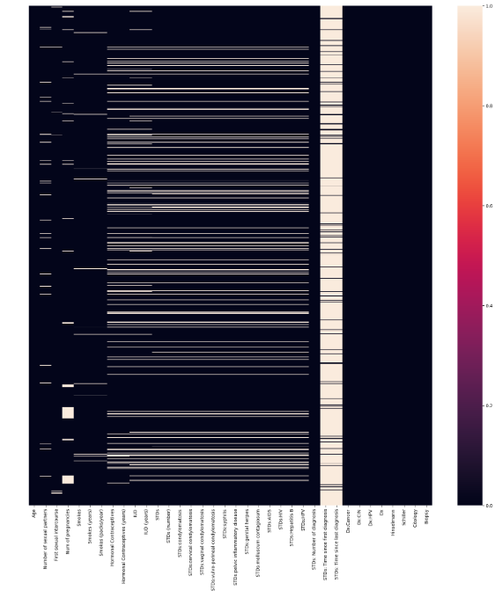
- Initial heatmap of missing values per column.
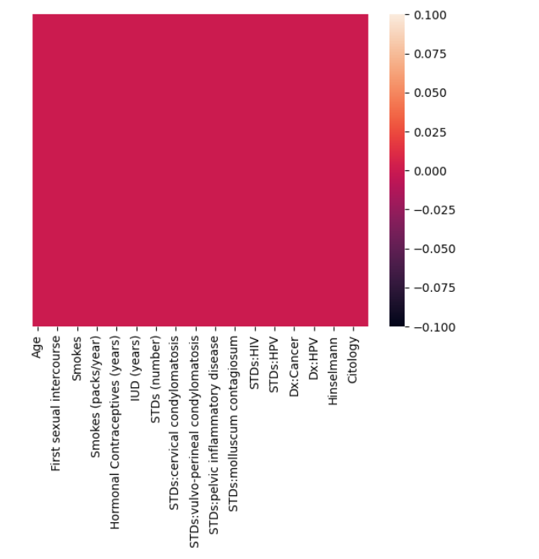
- Heatmap of missing values after data processing.

Exploratory Data Analysis
- Correlation Analysis: We generated a correlation matrix (Figure 4) which helped to understand the relationships between other features and the target variable i.e. “Biopsy”. The matrix helped to identify strong correlations which informed feature selection.
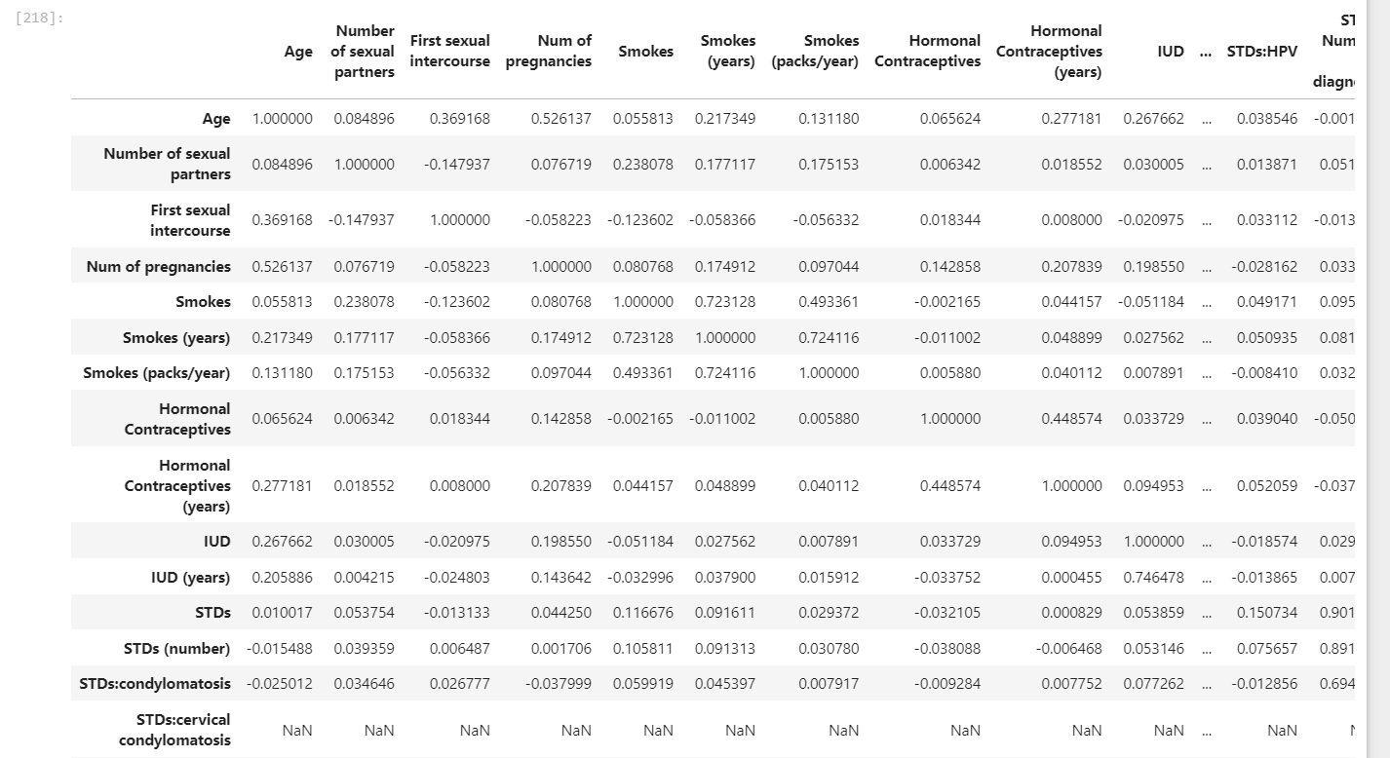
- A part of the correlation matrix plotted.
- Data Visualization: Histograms (Figure 5) of each feature were plotted to assess their distributions, identify skewness, and detect potential outliers. This visualization provided insights into the characteristics of the data, guiding preprocessing decisions such as scaling and normalization.
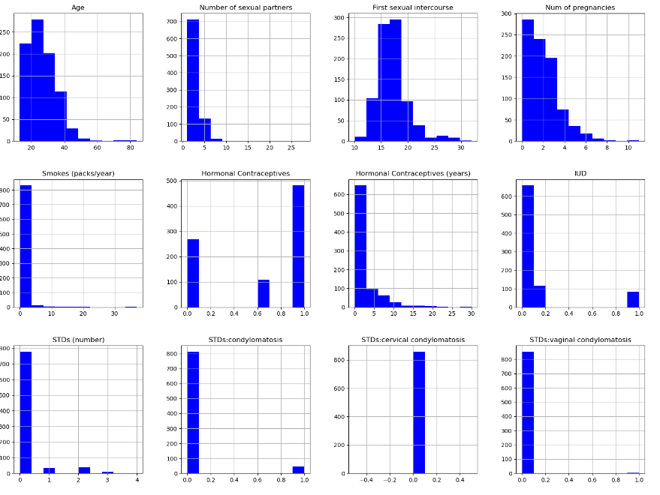
- Some of the histograms plotted.

- Correlation Matrix Heatmap: (Figure 6) This heatmap visualizes the pairwise correlations among features, highlighting key relationships and potential multicollinearity. Features with strong correlations to the target variable (Biopsy) are of particular interest for model training.
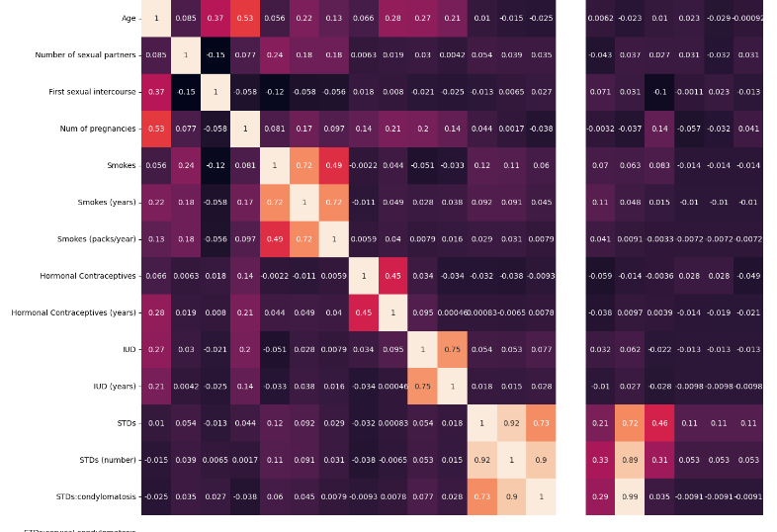
- A snippet of the heatmap plotted of the correlation matrix.

Data Splitting and Scaling
- Feature and Target Separation: The dataset was split into input features (X) and the target variable (y), with 'Biopsy' as the target variable representing the presence or absence of cervical cancer.
- Scaling: StandardScaler is used for standardization from scikit-learn to ensure the fact that all the features were on a comparable scale which is important for optimizing model performance.
- Train-Test-Validation Split: The dataset was divided into three parts: training, testing and validation sets. Initially a 80-20 split is used followed by a 50-50 split for validation and test sets. This approach ensures minimized overfitting.

Model Development

- Algorithm Selection: The choice for algorithm had to be made making sure it was well suited for this study. Hence, XGBoost Classifier algorithm was used for its robustness, efficiency and its ability to handle binary classification tasks.
- Handling Class Imbalance: Just like many medical diagnostic datasets in the used dataset as well there was class imbalance which was clearly noticeable. It was addressed by adjusting the scale_pos_weight parameter in the model. The ratio was set to the ratio of negative to positive samples in the training set which ultimately led to the minority class getting properly accounted. Class Imbalance Handling Diagram is given in figure 7.
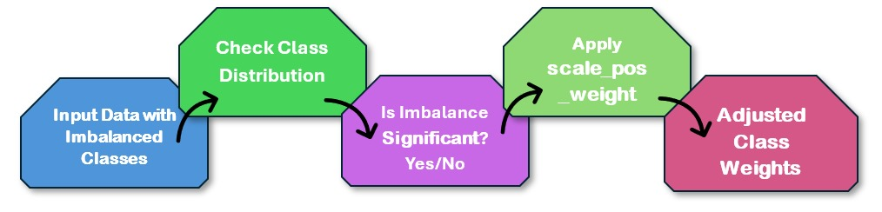
- Class Imbalance Handling Diagram.

Hyperparameter tuning
- Grid Search Cross-Validation: Hyperparameters of the XGBoost model were fine-tuned using GridSearchCV. The parameter grid included: Number of estimators (n_estimators), Maximum depth (max_depth), Learning rate (learning_rate), Subsample ratio (subsample), Column sample by tree (colsample_bytree) and Minimum loss reduction (gamma). The grid search used 5-fold cross-validation and was evaluated using the F1 score, appropriate for imbalanced datasets.

Results
In this section we present the final outcomes of our machine learning model aiming to predict cervical cancer risk. Here the performance metrics, visualizations and analysis of the results will be included. The evaluation used a test set as well just to ensure the correctness of the model on unseen data. The parameters like accuracy, precision, recall, F1 score and confusion matrices are used to identify the effectiveness of the model. We also present the ROC (Receiver Operating Characteristic) Curves to further show the model’s predictive capabilities.

Accuracy and Classification Reports
The accuracy, precision, recall and the F1 score for the test set is given in figure 8.
Accuracy is the total true predictions over the total number of predictions made. Precision is the proportion of correctly predicted positive observations out of all observations predicted as positive, indicating the accuracy of positive predictions. Recall is the proportion of correctly predicted positive observations out of all actual positive observations, reflecting the model's ability to identify true positives. F1 score is the harmonic mean of precision and recall, providing a single measure that balances both, especially useful when dealing with imbalanced classes. Their respective formulas are given below:-
Accuracy = 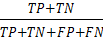
The formulas for precision, recall and F1 score are given below:
Precision = 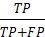
Recall = 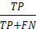
F1 = 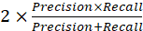
Where TP: True Positive
TF: True False
FP: False Positive
FN: False Negative

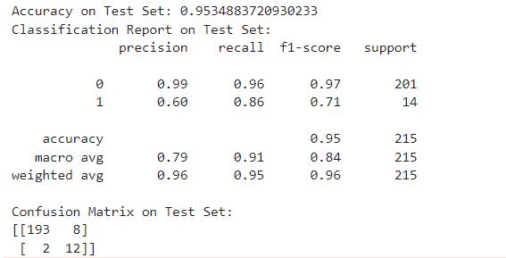
- Accuracy and classification report on the test set
The accuracy, precision, recall and the F1 score for the validation set is given in figure 9.
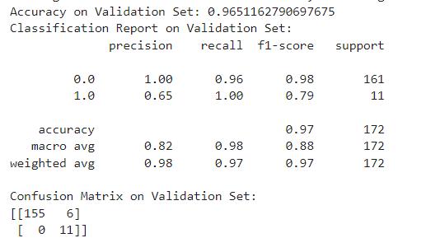
- Accuracy and classification report on the validation set
The accuracy for the training set was achieved to be 0.9689 or 96.89%.

Heatmap of confusion matrix
The heatmap of confusion matrix shows the distribution of true positives, true negatives, false positives, and false negatives, providing a detailed view of how well the model distinguishes between classes. It is given in figure 10 and 11 for test and validation sets respectively.
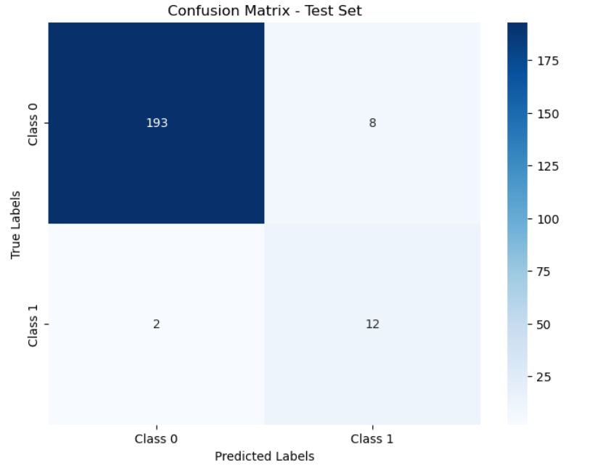
- Heatmap of the confusion matrix on test set
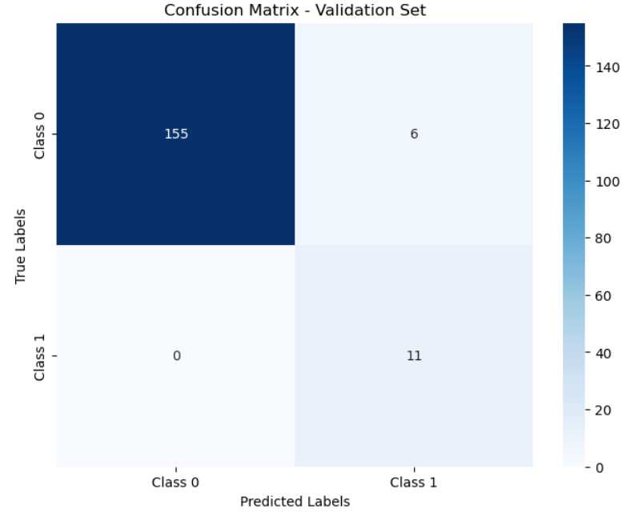
- Heatmap of the confusion matrix on validation set
The confusion matrix on the test set proves that the model is pretty accurate in predicting non cancer cases but should also aim to reduce the number of false negatives to ensure that no potential cases get overlooked. With more model tuning or evaluation strategies we can improve the precision, recall of class 1 as well.

ROC and AUC Curves
The ROC (Receiver Operating Characteristic) curve illustrates the trade-off between the true positive rate and false positive rate across various threshold settings, with the Area Under the Curve (AUC) indicating the model’s overall ability to discriminate between positive and negative classes. The closer AUC is to 1 the better the model is.
The ROC Curve along with AUC is given in figure 12.
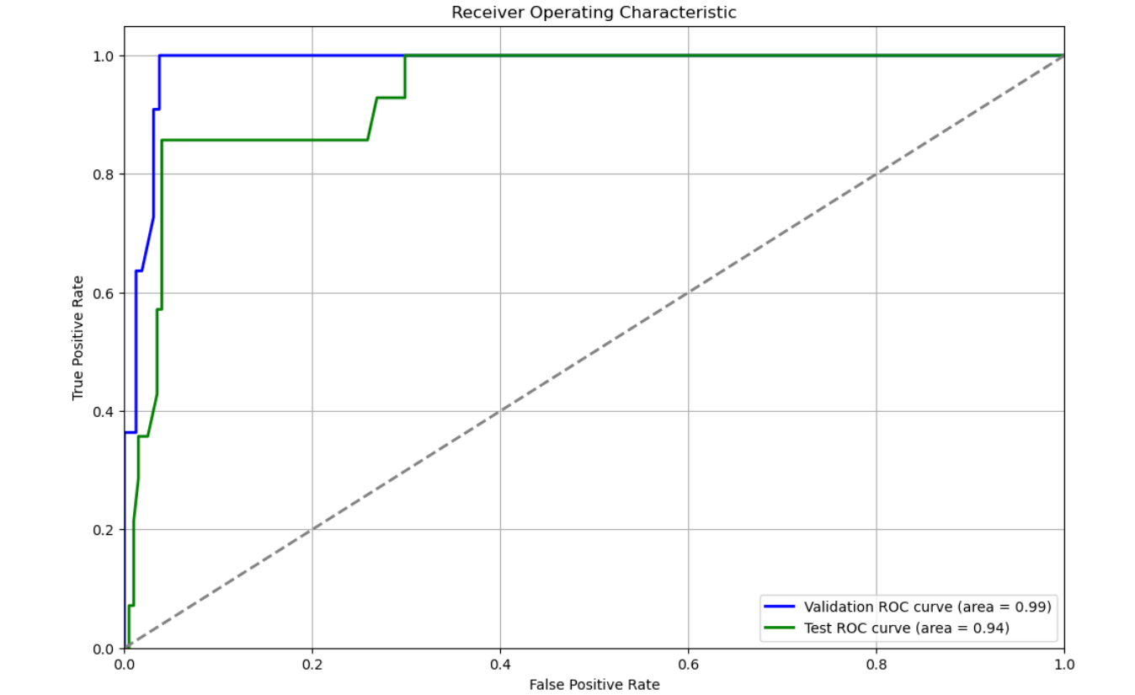
- ROC along with AUC Curve for test and validation sets.
As we can see the AUC for both the test and validation sets is more than 0.93. It shows that our model is pretty decent.

Discussion

Interpretation and Analysis
The model we have used achieves high accuracy (96.5% on validation and 95.35% on test sets) which demonstrates strong performance in predicting cervical cancer. Although the model excelled at identifying the negative cases it still showed lower precision for positive cases.

Comparison with Exisiting Literature
The high overall accuracy is similar to previous studies but the lower precision for positive cases poses as a discrepancy in our research. We used the scale_pos_weights parameter in XGBoost for its ease of implementation, direct integration with XGBoost, its computational efficiency and its simplicity in tuning. We come at the conclusion that using other techniques such as SMOTE, hybrid and deep learning approaches we can get around 80% precision in the positive class as well.

Implications
The model's strong performance indicates its potential utility in clinical settings for predicting negative cases. Improving precision for positive cases could enhance its effectiveness in early detection and diagnosis.

Limitations and Future Work

Cons: Low precision for positive cases and class imbalance in the dataset pose a challenge to this model. Further, the algorithm's performance may depend on other factors such as size of dataset and which features you pick.

Potential Future Work: use SMOTE or other balancing techniques to balance data, add new features and optimize the performance of the model by using different models which may hopefully improve prediction for positive class as well.

Conclusion

Model Performance
The XGBoost model along with scale_pos_weights achieved high accuracy (96.5% validation, 95.35% test) but showed lower precision for positive cases, indicating that while it effectively identifies negative cases, it needs improvement in detecting positive cases.

Class Imbalance Handling
We observed in our study that even though scale_pos_weights method seems efficient it will actually be better to use other techniques such as SMOTE or other hybrid deep learning techniques in order to gain a high precision in class 1 i.e. positive class as well.

Significance and Implications
The findings collectively emphasize the prediction power of XGBoost in cervical cancer and at the same time, highlights that more work could be directed to handle class imbalance data. Here, we based the model on this research to construct better predictive tools and feel that such advanced methods like SMOTE may ultimately provide better solutions in terms of precision as well as overall accuracy.
In conclusion, while the XGBoost model showed high accuracy, the scale_pos_weight method had limitations in precision for positive cases. Future research should explore combining XGBoost with SMOTE or other techniques to address these challenges more effectively.

References
The references used are as follows:
- • Chen, T., & Guestrin, C. (2016). XGBoost: A scalable tree boosting system. Proceedings of the 22nd ACM SIGKDD International Conference on Knowledge Discovery and Data Mining.
- Esteva, A., Kuprel, B., & Novoa, R. A. (2019). Dermatologist-level classification of skin cancer with deep neural networks. Nature, 542(7639), 115-118.
- • Haque, A., & Janarthanam, K. (2019). Handling class imbalance in medical datasets using SMOTE and its variations. IEEE Access, 7, 25636-25649.
- • Obermeyer, Z., & Emanuel, E. J. (2016). Predicting the future — Big data, machine learning, and clinical medicine. New England Journal of Medicine, 375, 1216-1219.
- • Al Mudawi, S., & Alazeb, M. (2020). A model for predicting cervical cancer using machine learning algorithms. Procedia Computer Science, 170, 452-458.
- • Chawla, N. V., Lazarevic, A., & Hall, L. O. (2002). SMOTE: Synthetic minority over-sampling technique. Journal of Artificial Intelligence Research, 16, 321-357.
- Andonie, R. (2006). Hyperparameter optimization in learning systems. In Proceedings of the International Conference on Machine Learning and Data Mining.

